CENIR CENTRE

Original Configuration
- Display area: 18° × 18° DVA (square)
- Fixation grid: 5×5 grid (25 positions)
- Spacing: 4.5° DVA between positions
- Pursuit amplitudes: 3, 5, 7 DVA
- Image format: 800×800 pixels (square)

New Configuration Summary

Display Specifications
- Available aperture: 26.2° × 14.8° DVA (maximum)
- Chosen stimulus area: 22° × 12.375° DVA (rectangular, 16:9 aspect ratio)
- Display resolution: 1920×1080 pixels
- Pixels per DVA: ~73.3 pixels/DVA

Stimulus Area Illustratiom

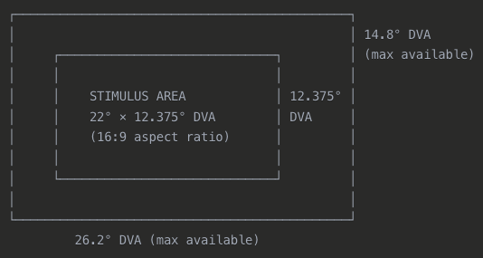

Grid Specifications
- Layout: 7×3 grid (21 positions total)
- Spacing: 3.67° DVA (equal in both directions)
- Coverage: Full stimulus area (22° × 12.375° DVA)
- Centering: Perfectly centered at [0,0]

Position | X (DVA) | Y (DVA) | Position | X (DVA) | Y (DVA) | Position | X (DVA) | Y (DVA)
1 | -11.0 | +6.19 | 8 | -11.0 | 0.0 | 15 | -11.0 | -6.19
2 | -7.33 | +6.19 | 9 | -7.33 | 0.0 | 16 | -7.33 | -6.19
3 | -3.67 | +6.19 | 10 | -3.67 | 0.0 | 17 | -3.67 | -6.19
4 | 0.0 | +6.19 | 11 | 0.0 | 0.0 | 18 | 0.0 | -6.19
5 | +3.67 | +6.19 | 12 | +3.67 | 0.0 | 19 | +3.67 | -6.19
6 | +7.33 | +6.19 | 13 | +7.33 | 0.0 | 20 | +7.33 | -6.19
7 | +11.0 | +6.19 | 14 | +11.0 | 0.0 | 21 | +11.0 | -6.19

Smooth Pursuit Task

Amplitude Changes
- Original: 3, 5, 7 DVA
- Updated: 3, 5, 6 DVA
- Reason: Maximum amplitude reduced to ensure all 18 angles work within rectangular boundaries

Angle Configuration
- Angles: All 18 original angles maintained (0°, 20°, 40°, ..., 340°)
- Boundary constraints:
  - Horizontal: ±11.0 DVA
  - Vertical: ±6.1875 DVA
- Validation: Automatic recomputation when movements exceed boundaries

Movement Validation
Maximum safe movement envelope:
┌─────────────────────────────────┐
│ │ ±6.1875 DVA
│ │ (vertical limit)
│ ● (center) │
│ │
│ │
└─────────────────────────────────┘
±11.0 DVA (horizontal limit)

6 DVA amplitude is safe for all 18 angles

Image Presentation Updates

Image Specifications
- Original format: 800×800 pixels (square)
- New format: 1613×903 pixels (16:9 aspect ratio)
- Conversion method: AI-powered expansion (Canva Magic Expand)
- Display area: Full stimulus area (22° × 12.375° DVA)

Image Processing Workflow
- Source: Square 800×800 images
- AI Extension: Expand to 1613×903 pixels using generative fill
- Aspect Ratio: 16:9 (matches stimulus area)
- Quality: No stretching or distortion of original content

